1. **Manage jenkins** and install **Deploy to container** and then , **install without restart** .
2. The below screenshot shows that , plugin is successfully installed .

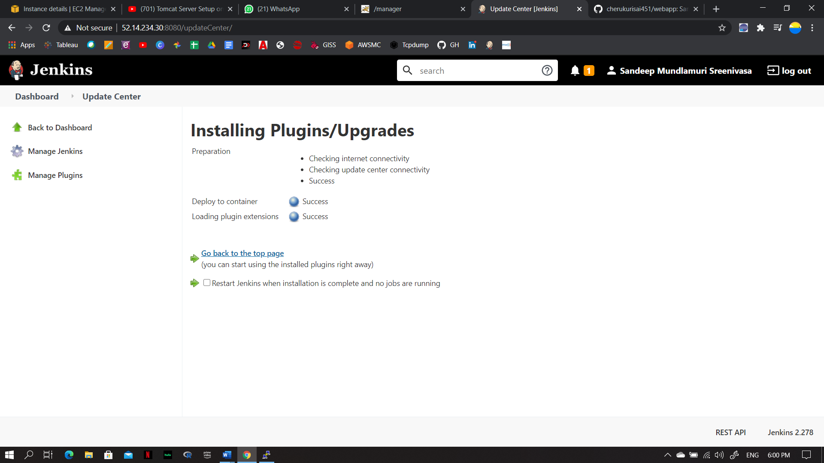

3.Now , create a freestyle project with a name , I created Tomcat_deploy.

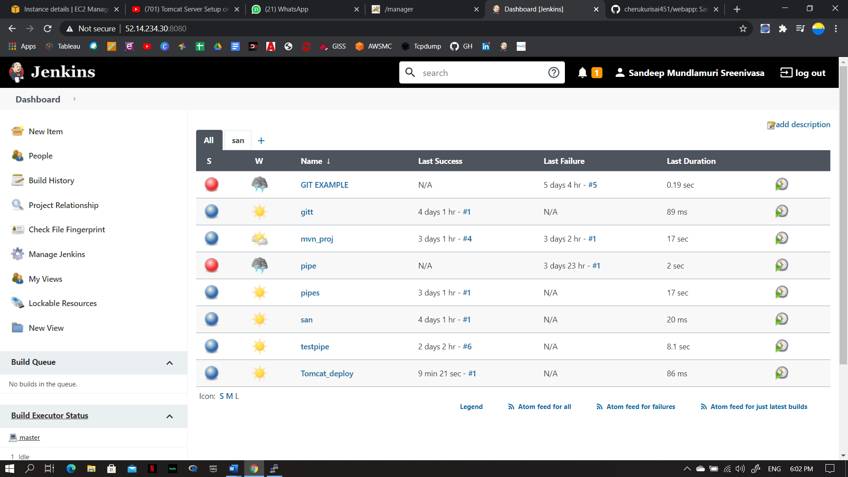

1. Now , configure Tomcat_deploy .
2. Now . select Git and paste URL for GIT repo.

I pasted from Sai webapp , from Git

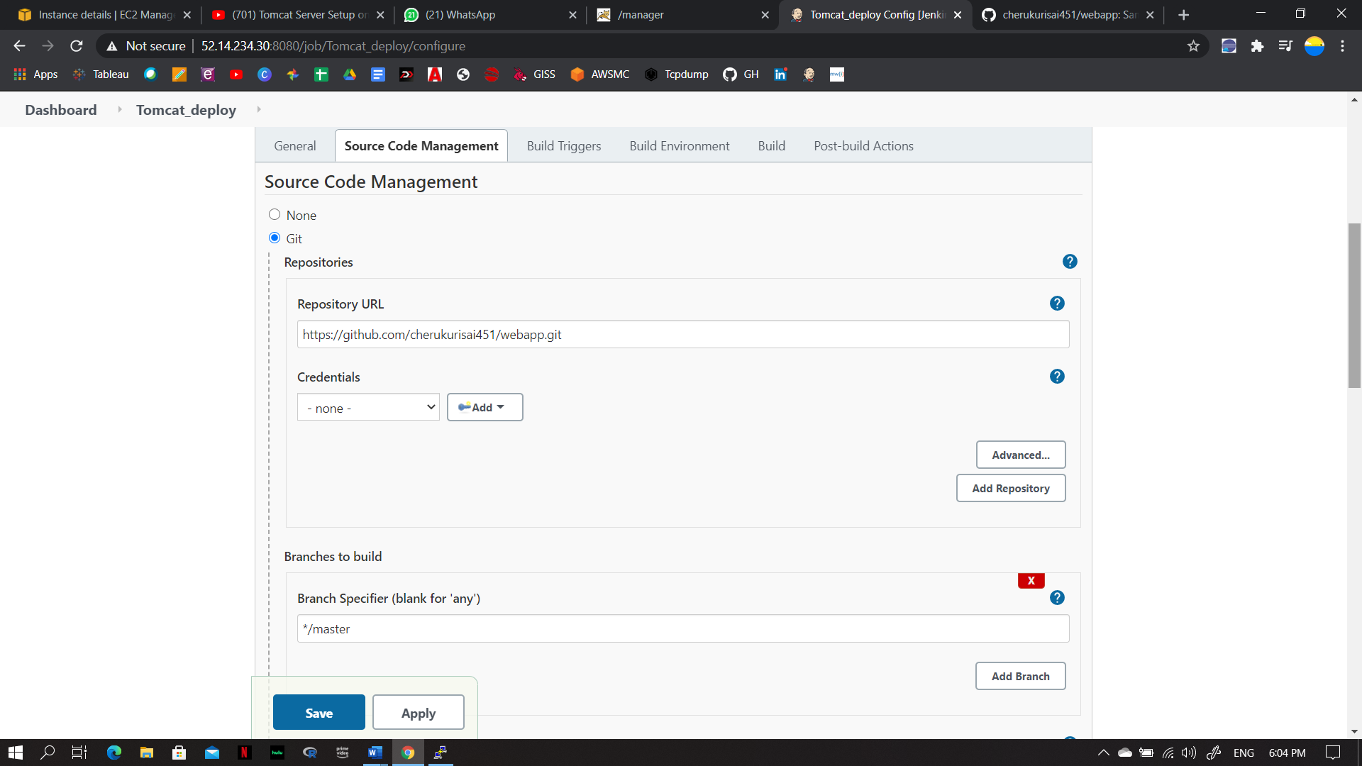

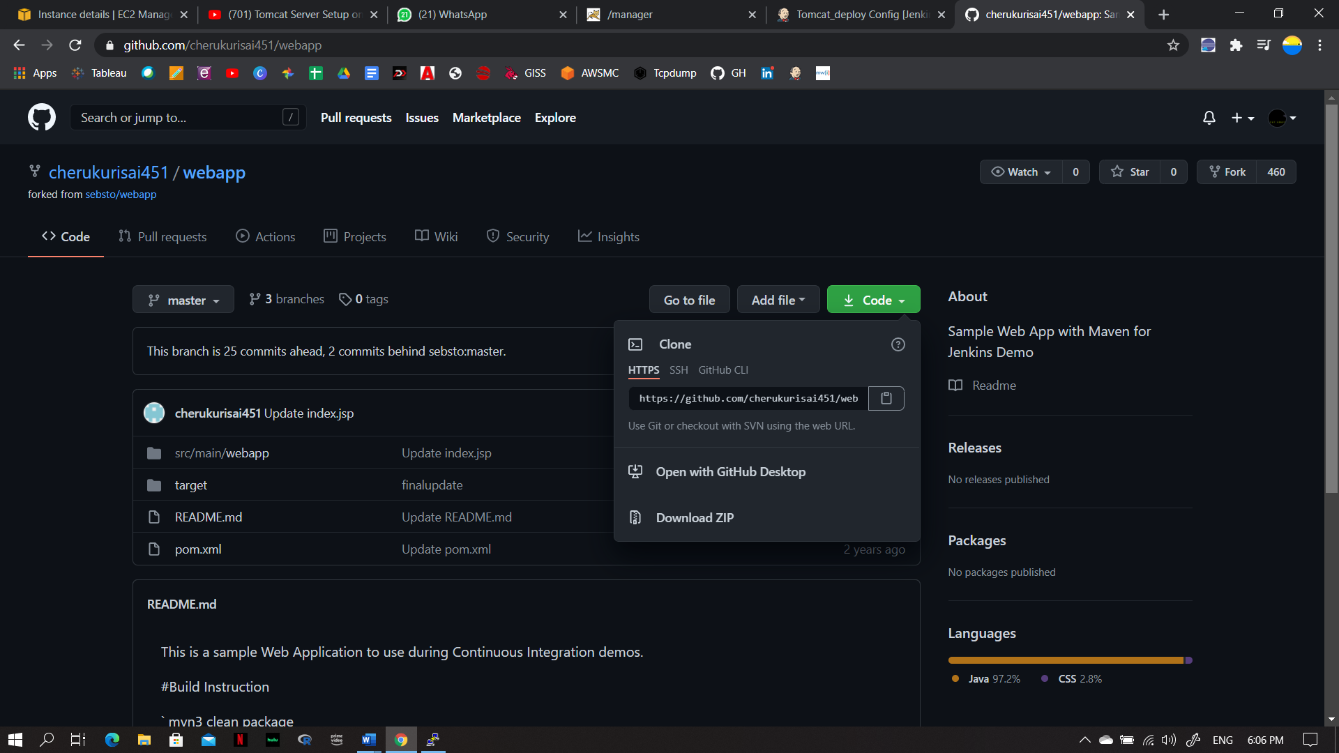

**Build :Maven** and **Goals** : **clean package**

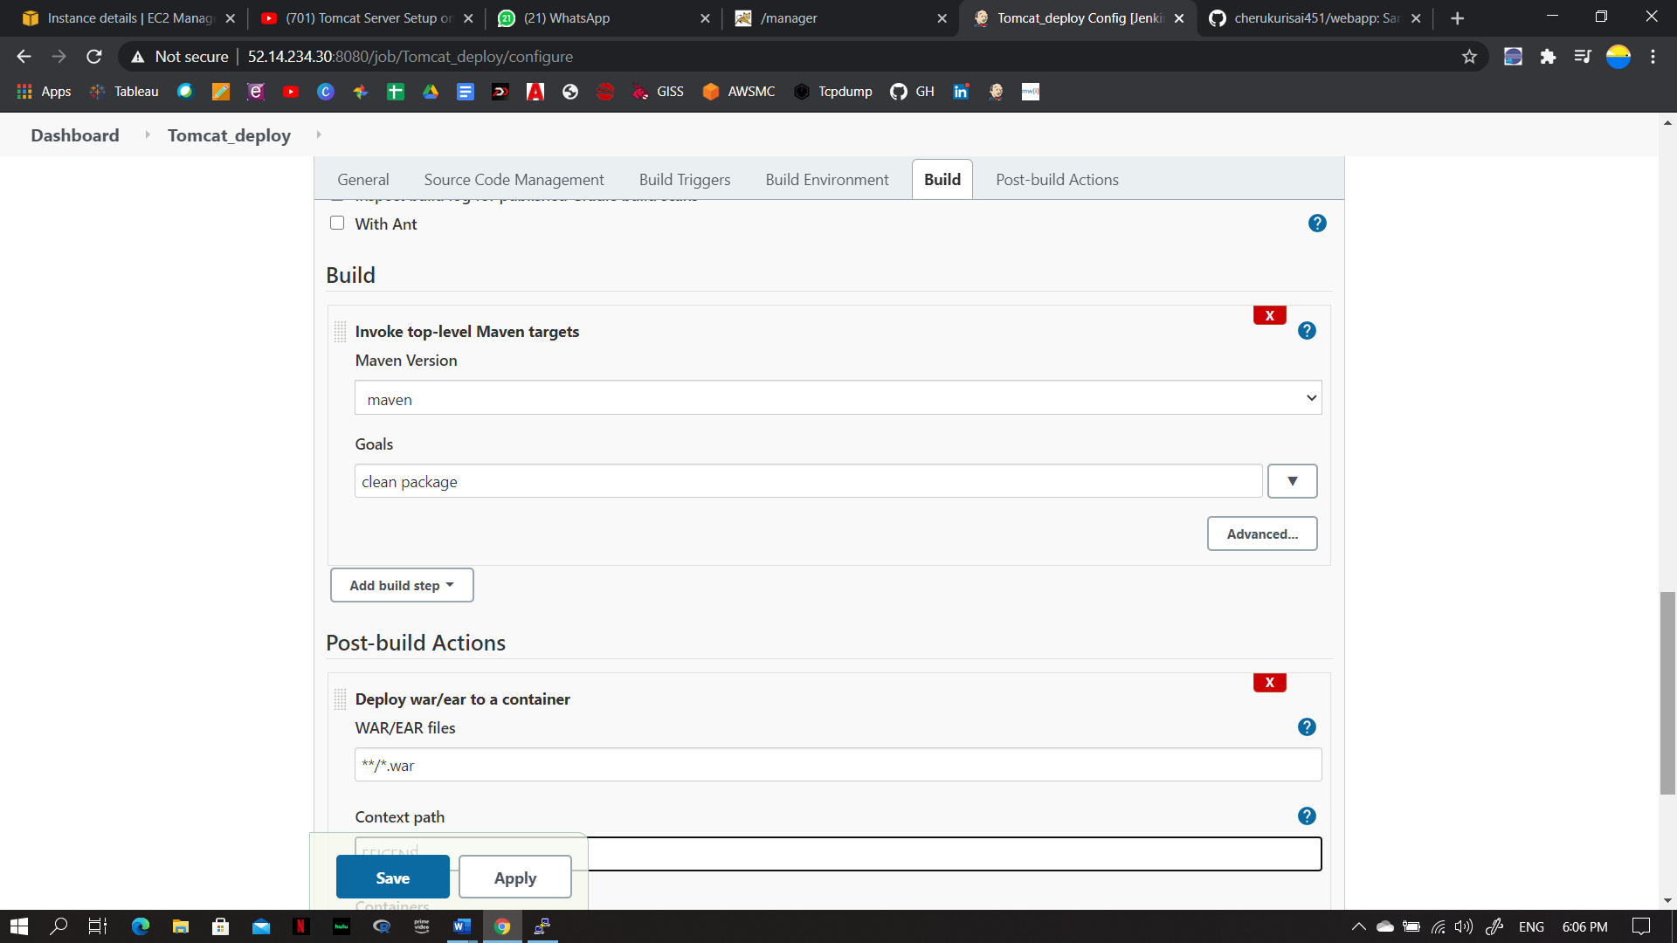

Post- build Actions : Deploy war /ear to a container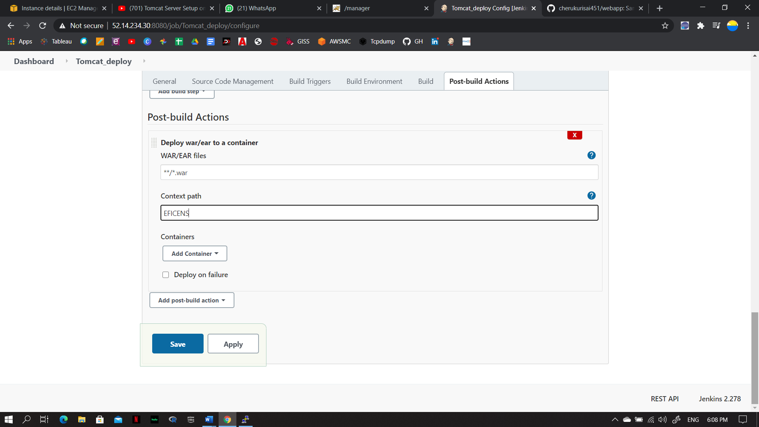

Credentials : enter the below ones .and select it

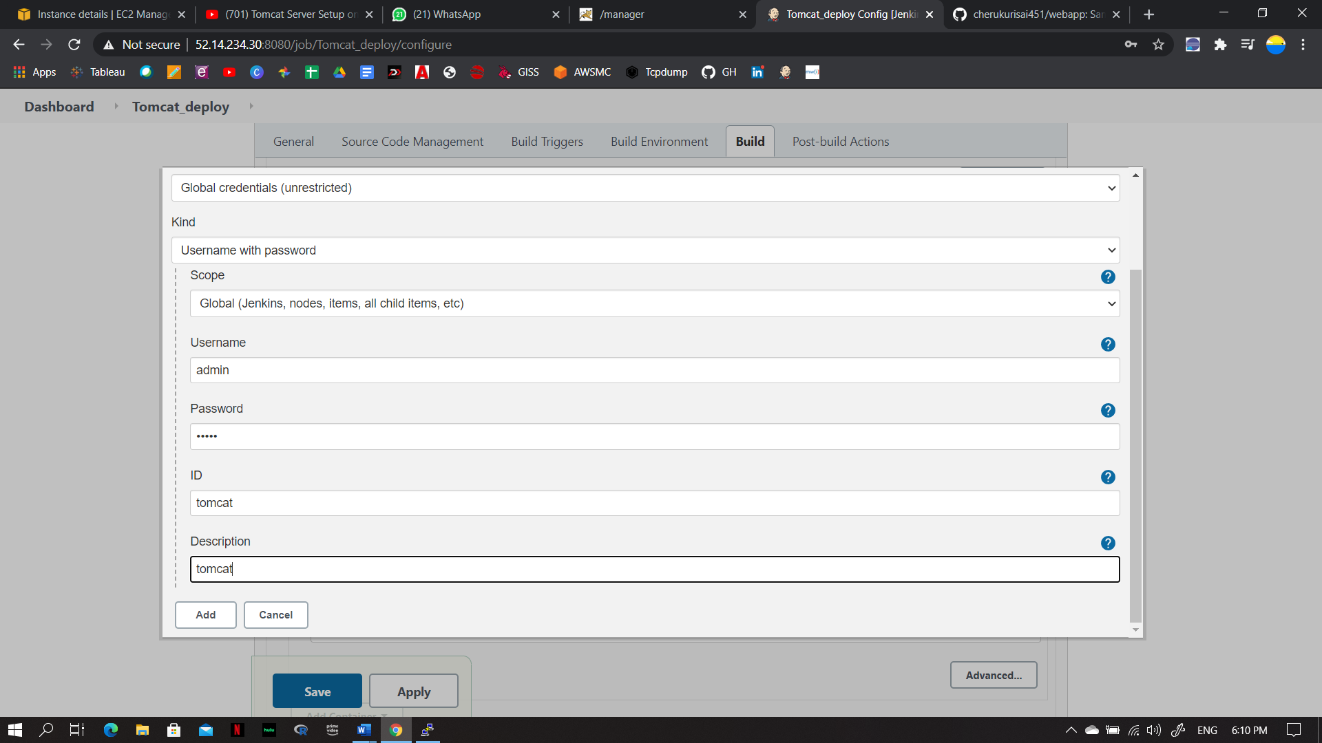

Now , Give the Tomcat launched IP address along with the port

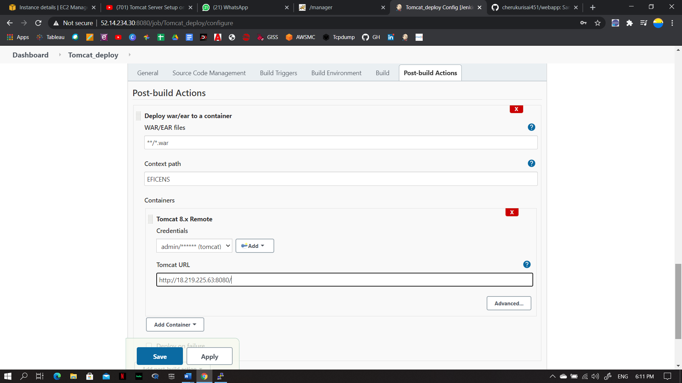

Now , the build is successful .

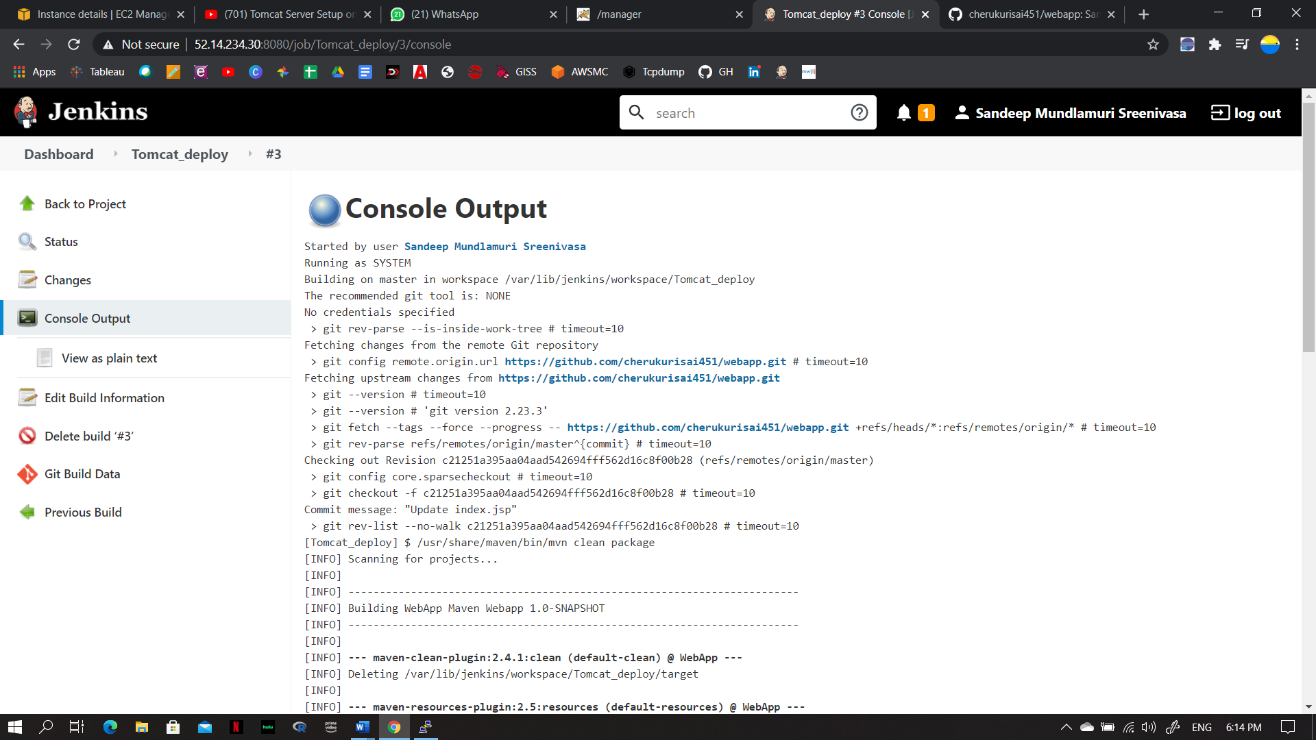

EFICENS is deployed on the tomcat server .

